**## Install Forecast Package**

install.pacakges('fpp')

library(fpp)

data(ausair)

air <- window(ausair,start=1990,end=2004)

plot(air,ylab="Airline Passengers", xlab="Year")

**## SES Method - Alpha =0.2**

fit1 <- ses(air, alpha=0.2, initial="simple", h=3)

**## change alpha to 0.6**

fit2 <- ses(air, alpha=0.6, initial="simple", h=3)

**## Use all Default VAlues**

fit3 <- ses(air,h=3)

**## Now Plot SES trends on existing graph**

plot(fit1, PI=FALSE, ylab="Airline Passengers", xlab="Year", main="", fcol="White", type="o")

lines(fitted(fit1), col="blue", type="o")

lines(fitted(fit2), col="red", type="o")

lines(fitted(fit3), col="green", type="o")

lines(fit1$mean, col="blue", type="o")

lines(fit2$mean, col="red", type="o")

lines(fit3$mean, col="green", type="o")

**## Green Line - 0.9 alpha seems to capture the trend the best**

**## Add a Legend**

legend("topleft", lty=1, col=c(1, "blue", "red", "green"), c("data", expressions(alpha==0.2),

expressions(alpha==0.6), expressions(alpha==0.89)),pch=1)

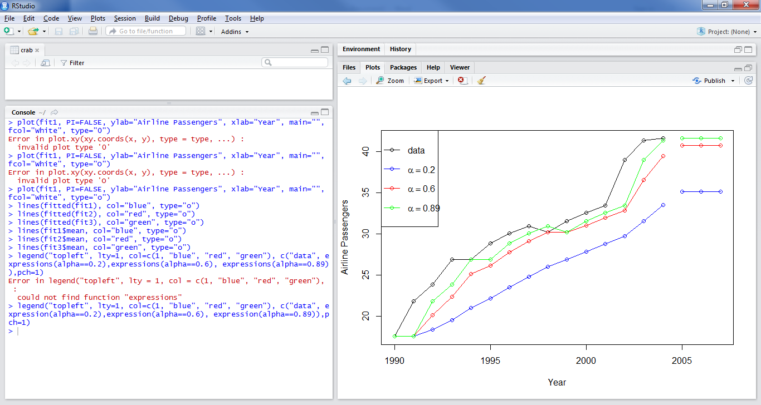

**## Now use Holt’s Method – no flat-line forecast**

fit1 <- holt(air, alpha=0.8, beta=0.2, initial="simple", h=5)

fit2 <- holt(air, alpha=0.8, beta=0.2, initial="simple", exponential=TRUE,h=5)

fit$model$state

plot(fit2, type="o", ylab="Air Passengers in Australia (millions)", xlab="Year", fcol="white", PI=FALSE, main="Forecast Using Holt's Methods")

**## Plot the Fitted Model Using the Additive Model – Linear**

> lines(fitted(fit1), col="blue")

**## Plot the Fitted Model Using the Multiplicative Model – Exponential**

> lines(fitted(fit2), col="red")

**## Plot the Forecasted Trends for Each Model**

lines(fit1$mean, col="blue", type="o")

lines(fit2$mean, col="red", type="o")

**## The Linear Trend is straight while the Exponential is a constant growth rate. May need to use a Dampening method to slow the growth rate down for the Exponential form**

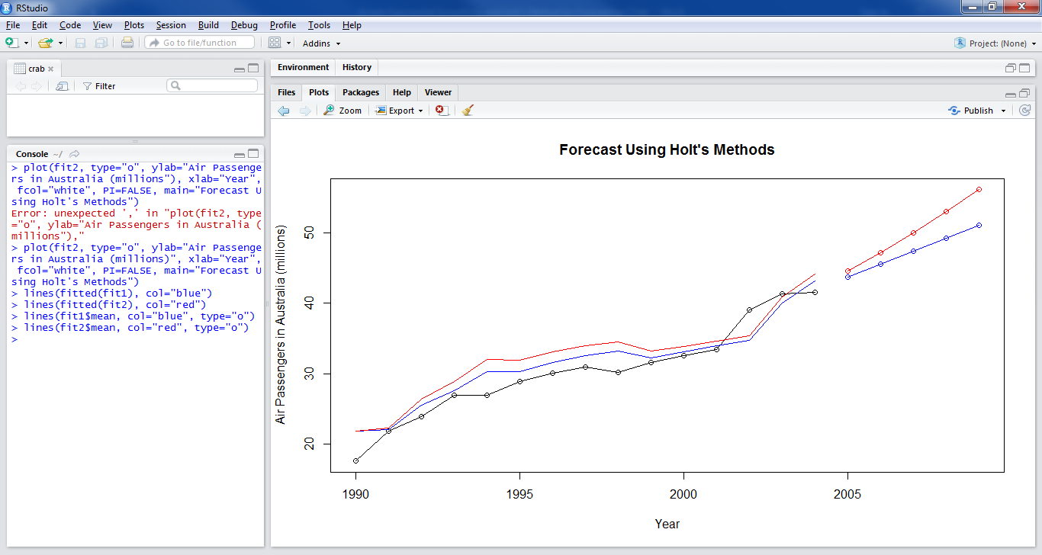

**Damped Method**

## Damped additive trend

fit4 <- holt(air,alpha=0.8, beta=0.2, damped=TRUE, intitial="simple", h=5)

lines(fitted(fit4), col="darkgreen")

lines(fit4$mean, col="darkgreen", type="o")

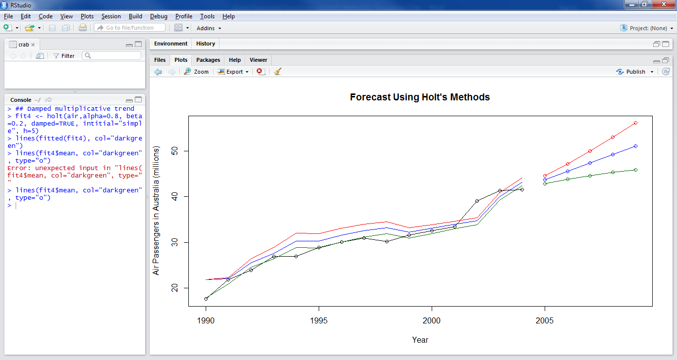

fit3 <- holt(air, exponential=TRUE)

fit5 <- holt(air, damped=TRUE, exponential=TRUE)

fit1$model

AIC AICc BIC

71.48990 73.67172 73.61406

fit2$model

AIC AICc BIC

64.33833 71.00500 67.87858

fit3$model

AIC AICc BIC

72.26039 78.92705 75.80064

fit4$model

AIC AICc BIC

63.71544 67.71544 66.54764 BEST MODEL BASED ON LOWEST AIC

fit5$model

AIC AICc BIC

69.02629 79.52629 73.27459

accuracy(fit4,ausair)

ME RMSE MAE MPE MAPE MASE

Training set 0.3317307 1.653933 1.084962 0.7156323 3.371681 0.591943

Test set 3.8715783 4.131618 3.871578 7.8802382 7.880238 2.112290

ACF1 Theil's U

Training set 0.1675855 NA

Test set 0.2453622 2.086233

lines(window(ausair,start=2005), type="o")

lines(fit1$mean,col=2)

lines(fit2$mean,col=3)

lines(fit4$mean,col=5)

lines(fit5$mean,col=6)

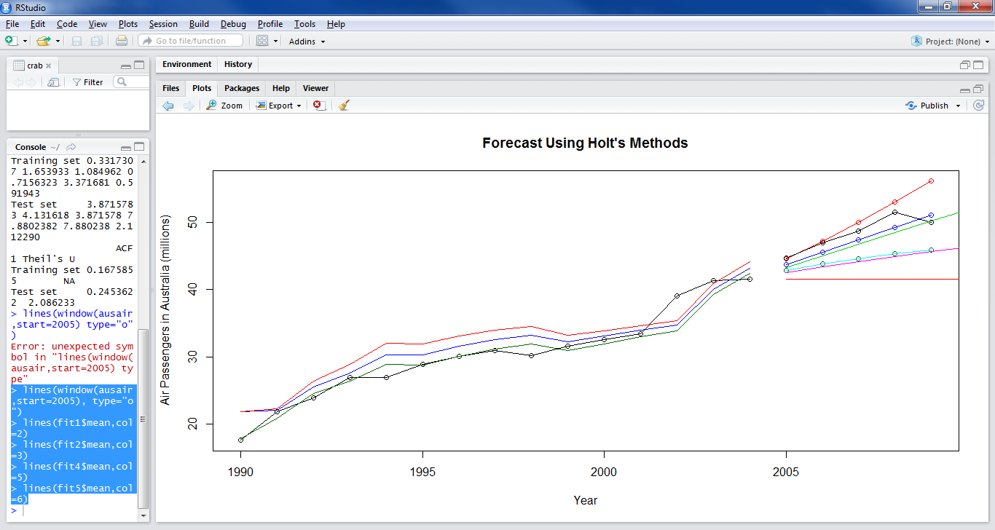

The Damped Multiplicative Trend Model is usually the best approach, based on the purple line above.

Example for Data with Seasonal Components

data("austourists")

aust <- window(austourists,start=2005)

fit1 <- hw(aust,seasonal="additive")

fit2 <- hw(aust,seasonal="multiplicative")

plot(fit2,ylab="International visitor night in Australia (millions)", PI=FALSE, type="o", fcol="white", xlab="Year", main="(Comparing Seasonal Methods")

lines(fitted(fit1), col="red", lty=2)

lines(fitted(fit2), col="darkgreen", lty=2)

lines(fit1$mean, type="o", col="red")

lines(fit2$mean, type="o", col="darkgreen")

legend("topleft", lty=1, pch=1, col=1:3, c("data", "Holt Winters' Additive", "Holt Winters' Multiplcative"))

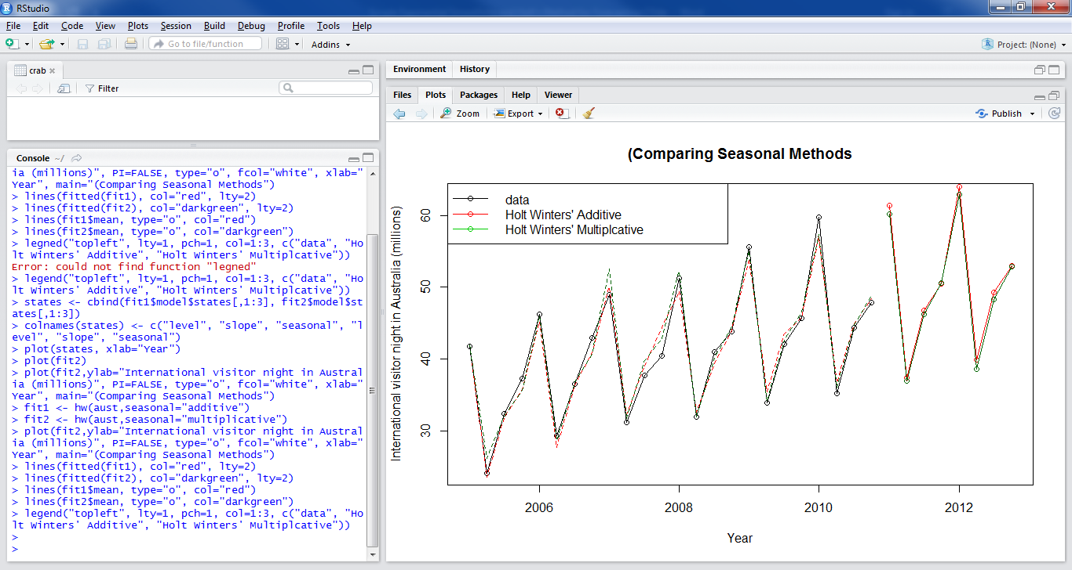

states <- cbind(fit1$model$states[,1:3], fit2$model$states[,1:3])

colnames(states) <- c("level", "slope", "seasonal", "level", "slope", "seasonal")

plot(states, xlab="Year")

## Simple Statistics on residuals

mean(fit1$residuals)

[1] 0.04228618

mean(fit2$residuals)

[1] -0.008212611

sd(fit1$residuals)

[1] 1.551616

sd(fit2$residuals)

[1] 0.03408463